- bluetooth mic to computer during live coding montages

- film footage of you going to the gym, roofdeck, drive with friends

- ask friends to film you while you have your mic on

- in idle moments leave the camera on so you can get more footage and you cut redundant and unneeded footage during editing

- stock non copy right music on youtube

Scott buckley

Aerohead

For you music Just make sure to credit them in monetized videos

- keep family private

- use handbrake as much as possible to compress final output file after editing

**Sound Board Websites**

From reddit:

<https://www.zapsplat.com/>

<https://freesound.org/>

**Music Board Websites**

https://studio.youtube.com/channel/UCzEGq6ncsfh7anueYEQvqqg/music

crediting from scott buckley - [Music by] or [Additional Music by] or [Track Title] by Scott Buckley –released under CC-BY 4.0. [www.scottbuckley.com.au](http://www.scottbuckley.com.au)

Simply put – this means that the music in this library is **free even for commercial use**, as long as attribution is given.

crediting from Argofox (<https://www.youtube.com/@Argofox>) –

Music provided by Argofox:

Dugn1r - 45 Degrees

Dugn1r - 45 Degrees [Argofox Release]

**Timelapsing videos**

To be honest, I wouldn't produce a timelapse with hours of video, I'd do it with images instead.

It's likely the effect that is causing the render to take so long. I don't think that's quite what Posterise Time was meant to be used for. Just how many hours of footage are you trying to speed up? And how long is the outcome going to be? Are we talking turning 12 hours of footage into 30 seconds?

The most important thing is determining how the format of your videos would look like

1. Types of Frames/Footage

* Black background with static sound
* Black background with label of maybe date in yellow or mustard color
* Narrations or subtitles must be in that mustard color
* Color grading must be that of zilds music video kyusi
* Timelapsed clip of 10 seconds for 10 hours footage
* POV Footage of travelling on motorcycle or ferry or car,
* Third person footage of me driving car
* Pov footage of roof deck sunset
* Pov footage of walking on the parking lot
* Pov footage of walking and the wonderful views of architecture or nature I see
* Third person footage of me cooking
* Third person footage of me coding or working
* Third person footage of me working out
* Third person footage of me on the roof deck
* Third person of me standing and feeling the cold breeze
* Third person of me reading a book
* Third person of me prepping to go to sleep sleeping
* Third person of me playing guitar
* Third person of me getting out of bed

Routes

PUP Pasig River Ferry Station to Escolta Station

Escolta station to Rizal Park is 2.1km

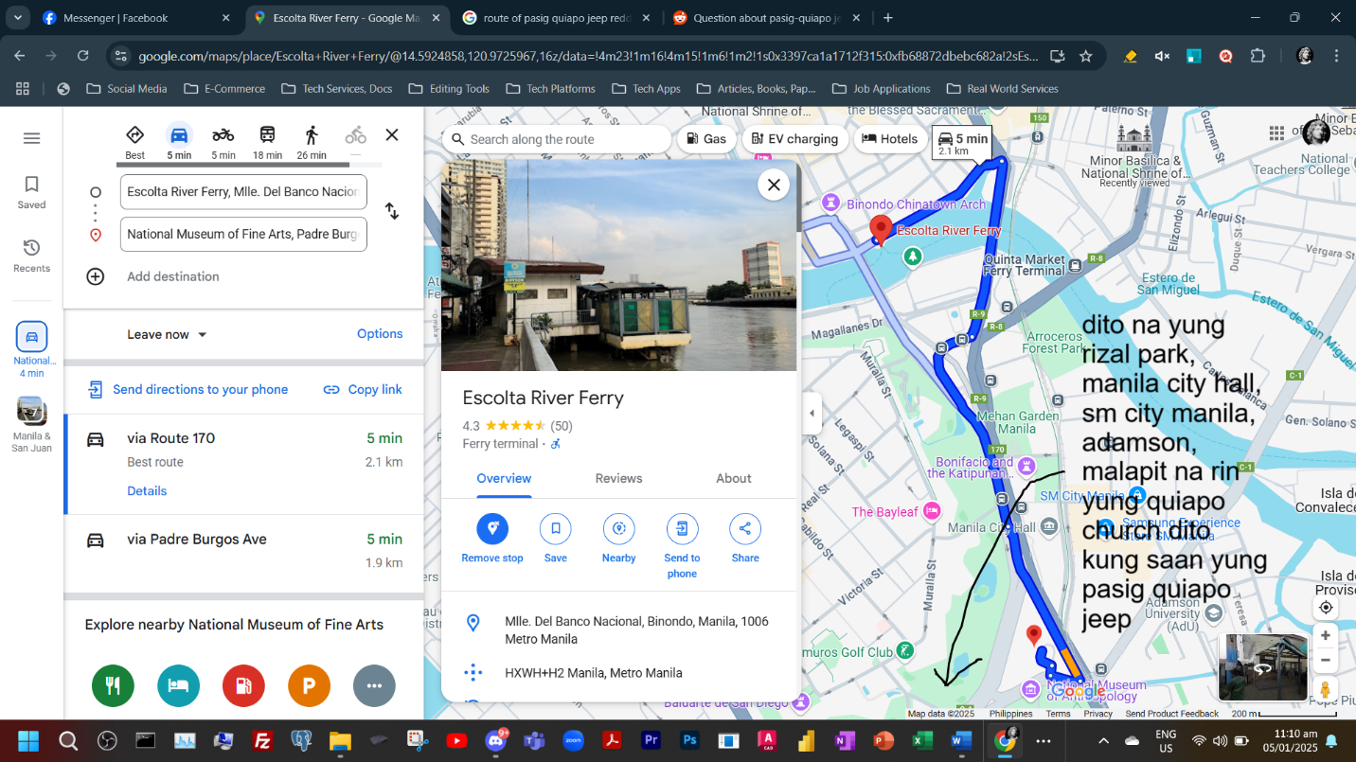

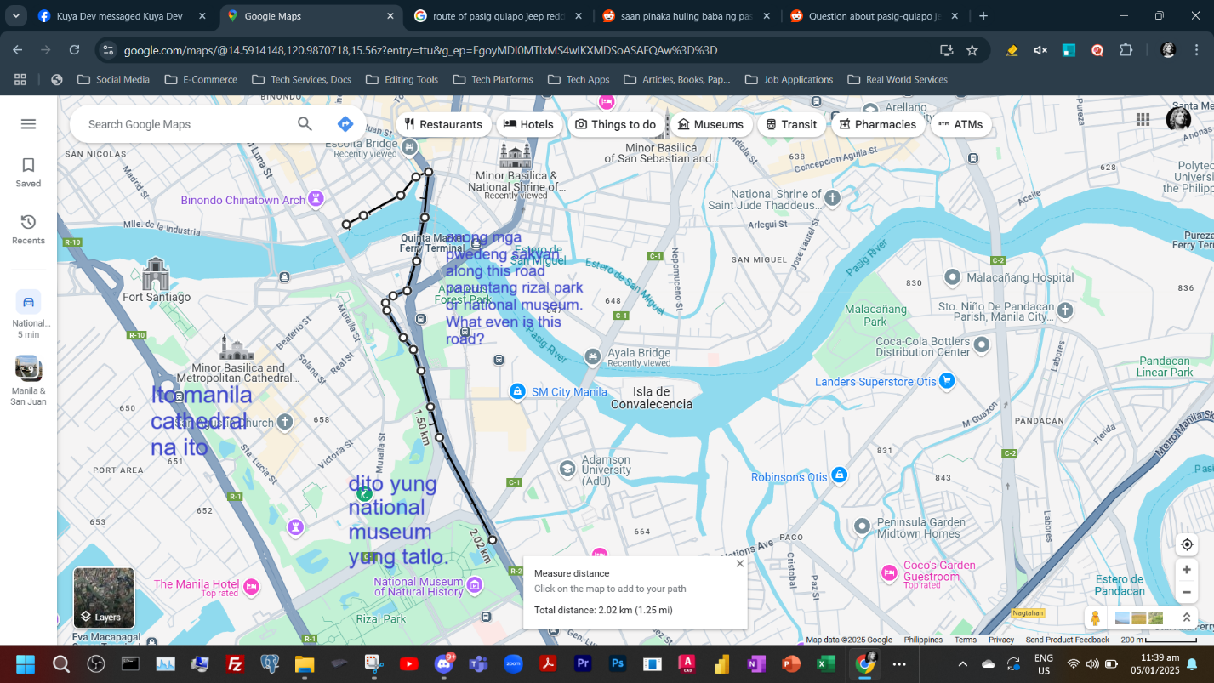

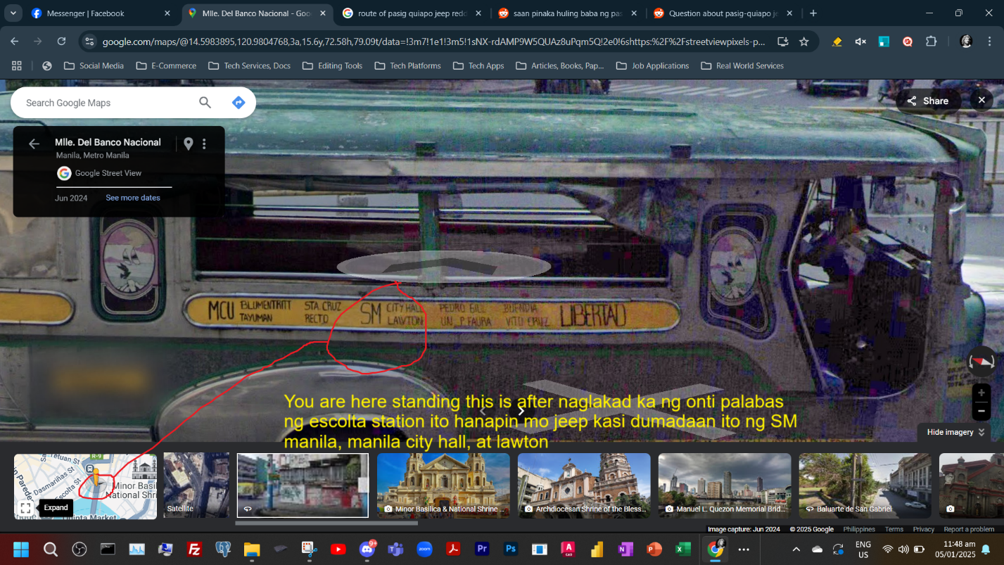

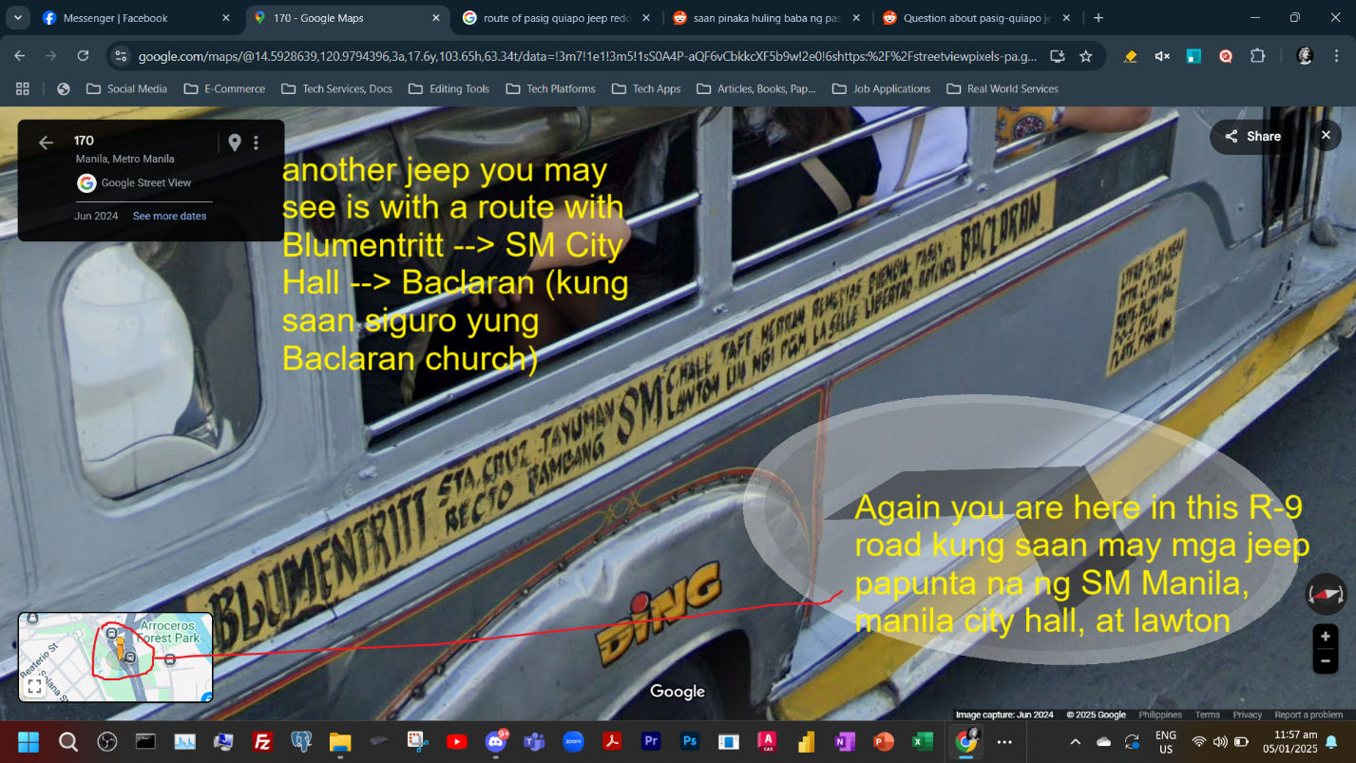

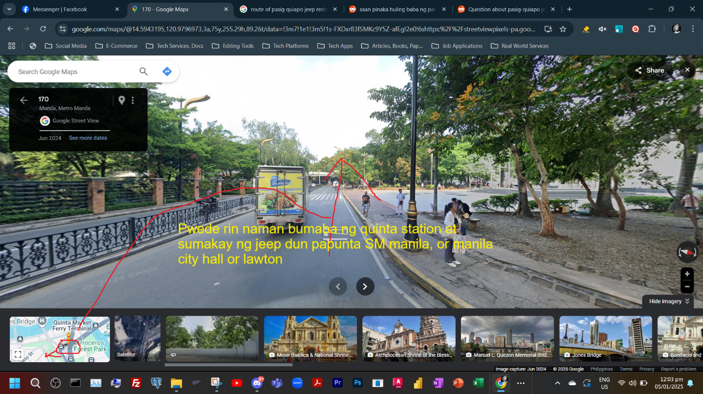

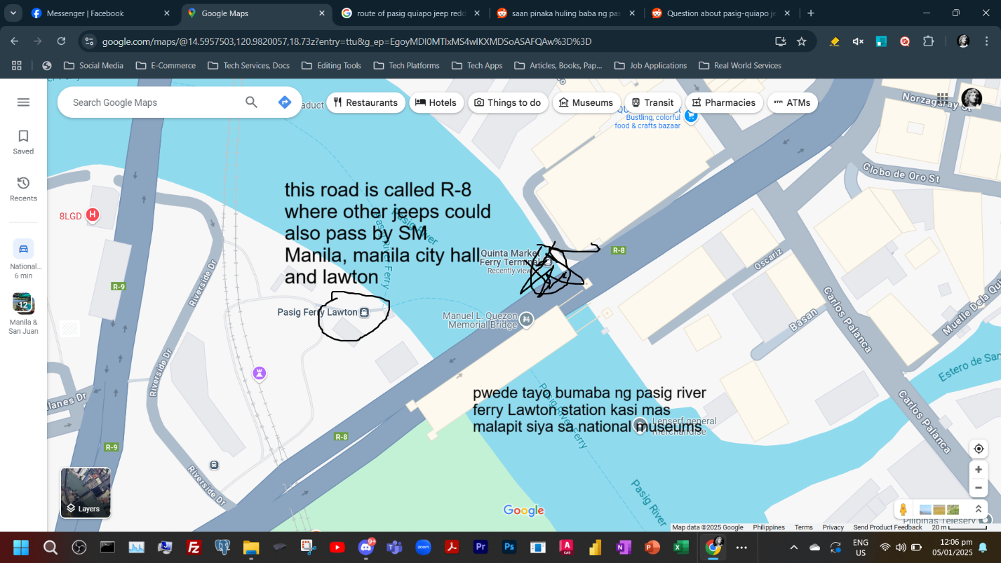

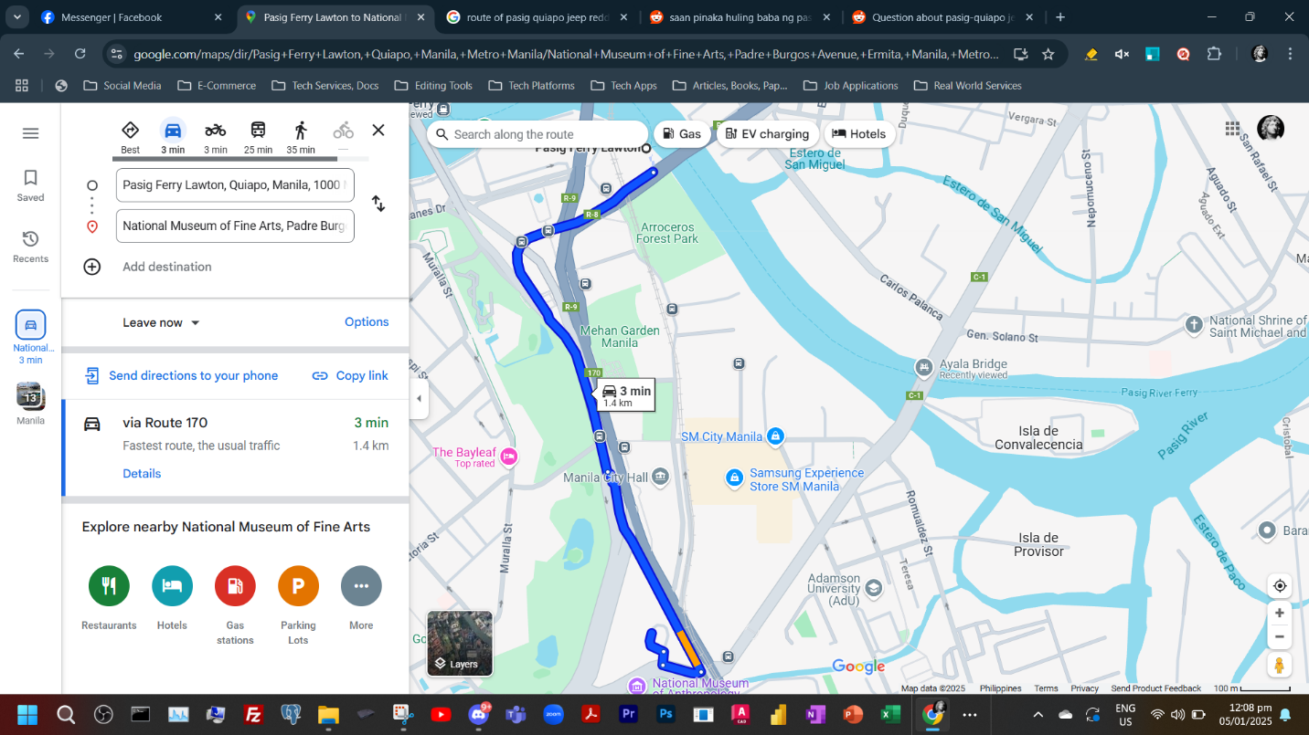

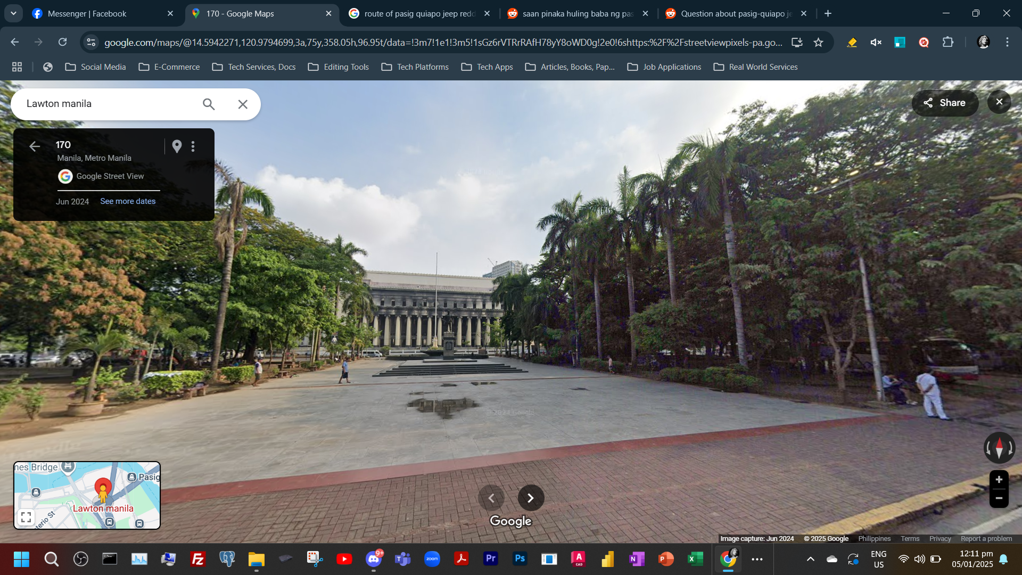

Could be a could shot this is along R-8 road. Lawton is what this is.

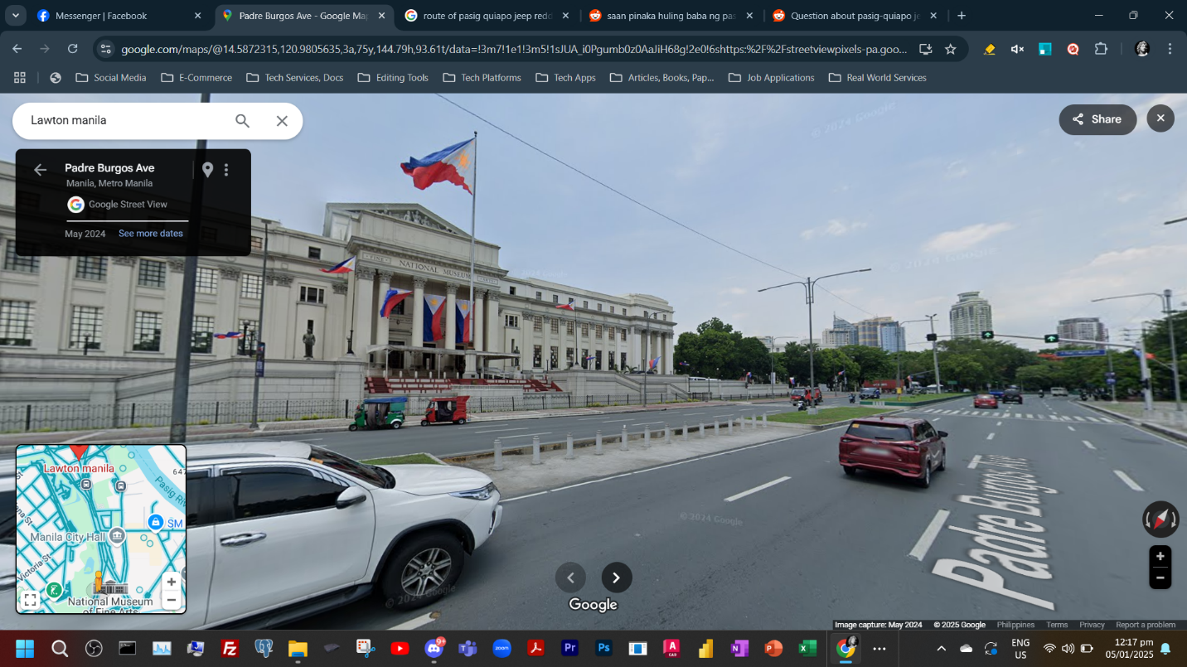

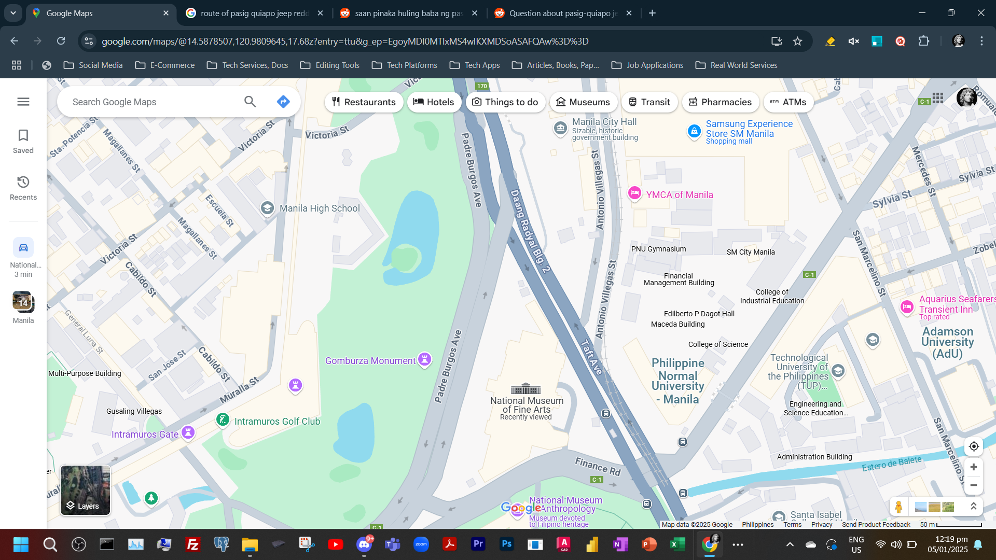

Take note this shot is shot from the padre burgos ave. side of the road not road R-2 which is the dark gray road.

Area of pasig quiapo from pasig palengke to quiapo church

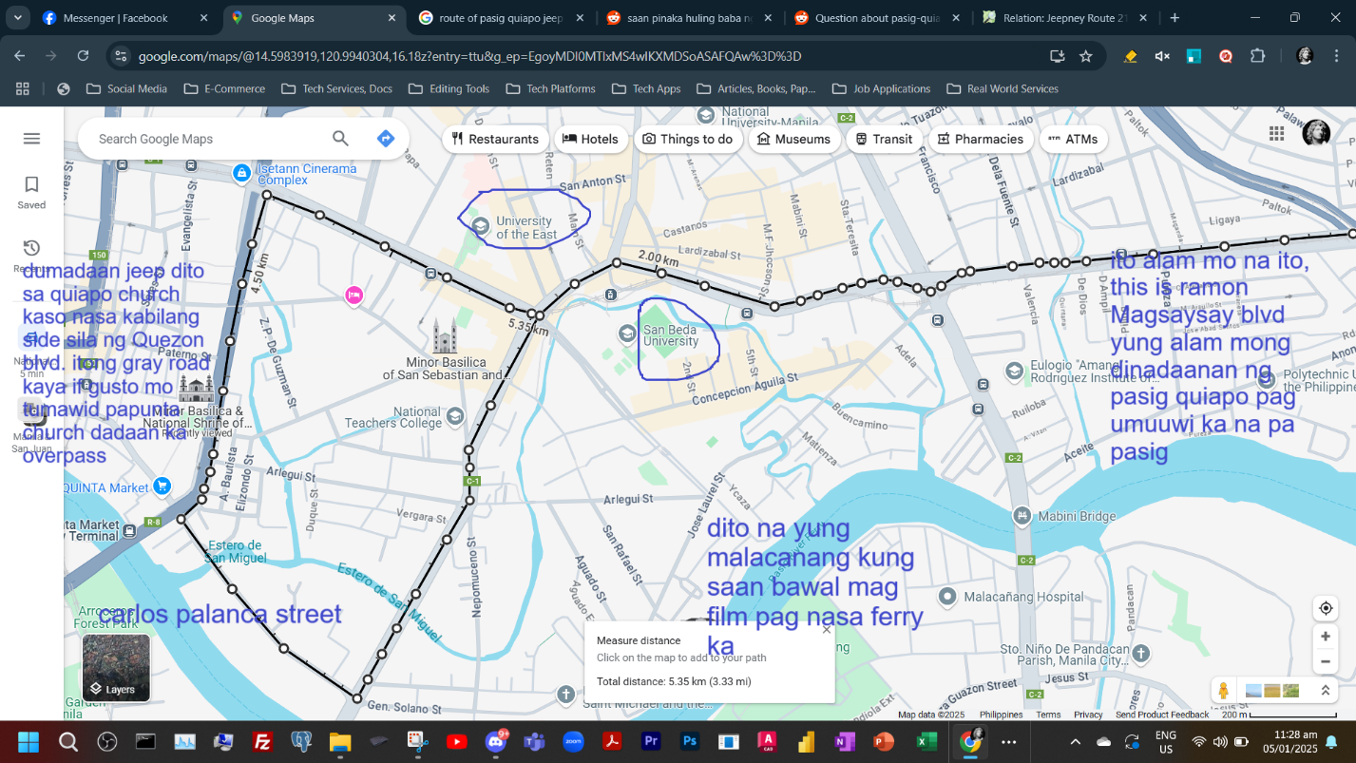

Yung bakal na bridge na hindi na dinadaanan ng jeep bago sila kumanan sa carlos palanca street yun yung ayala bridge

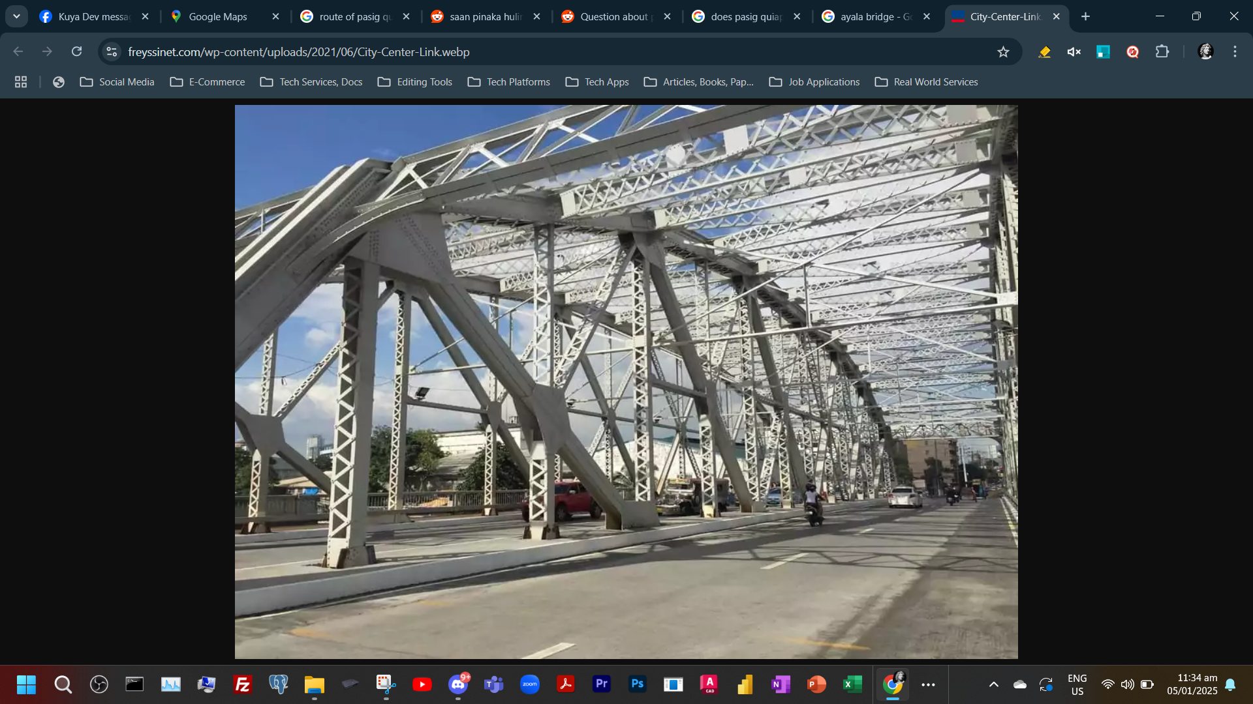

Things to do in Intramuros:

Walls’ Famous Spicy Chicken

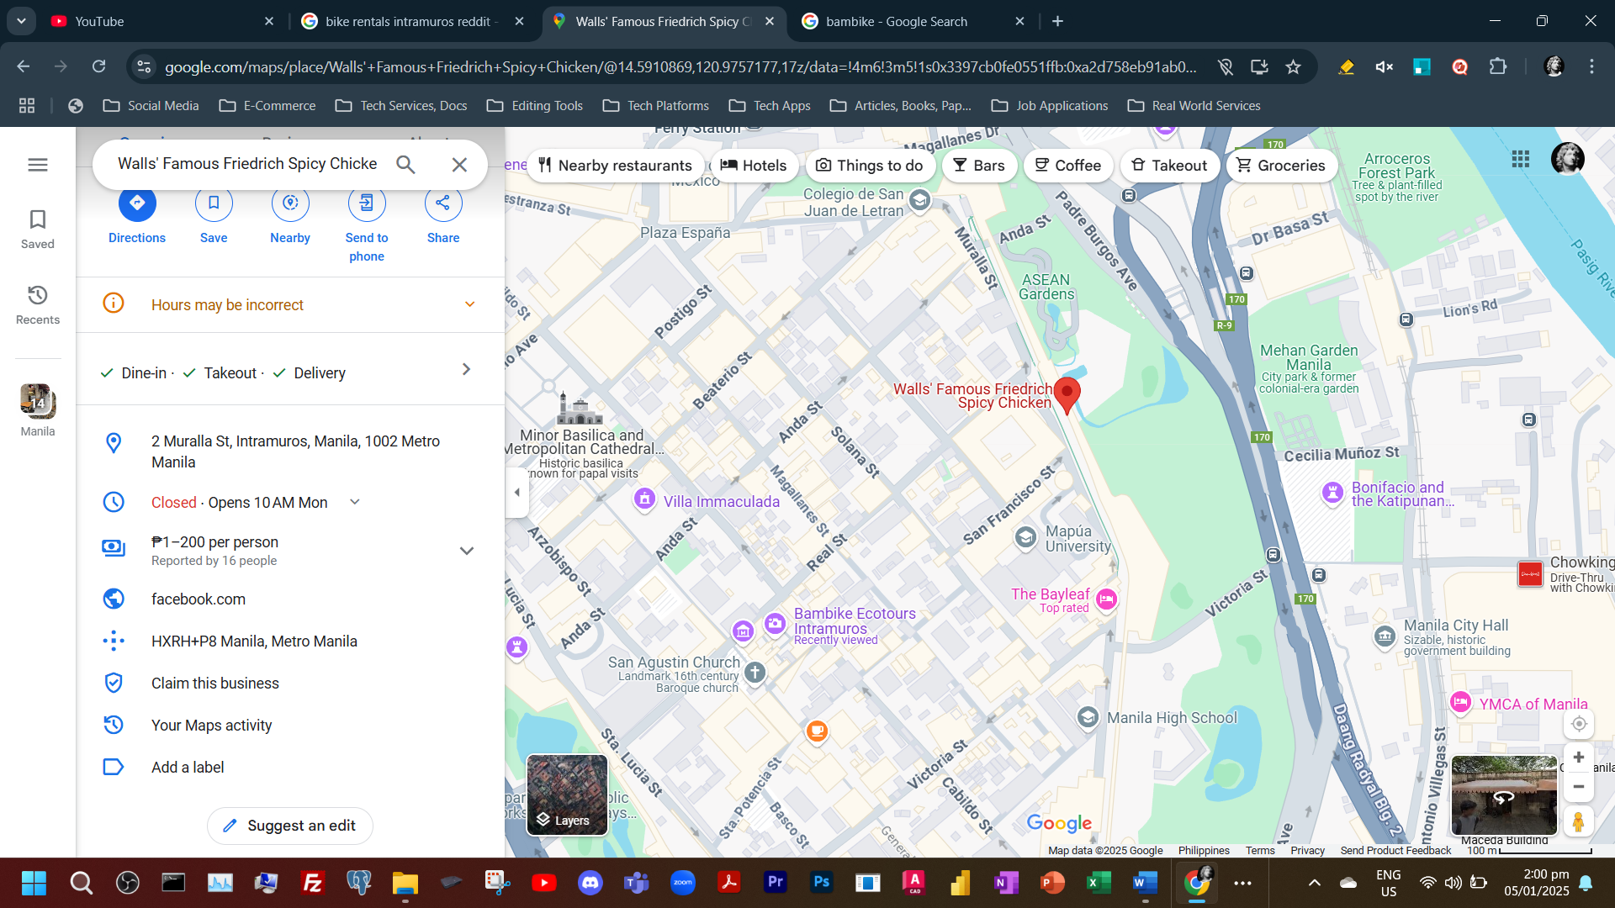

Walk on the walls surrounding Intra

Bamboo bike rental (₱50/hour if may student ID, ₱100 if wala afaik)

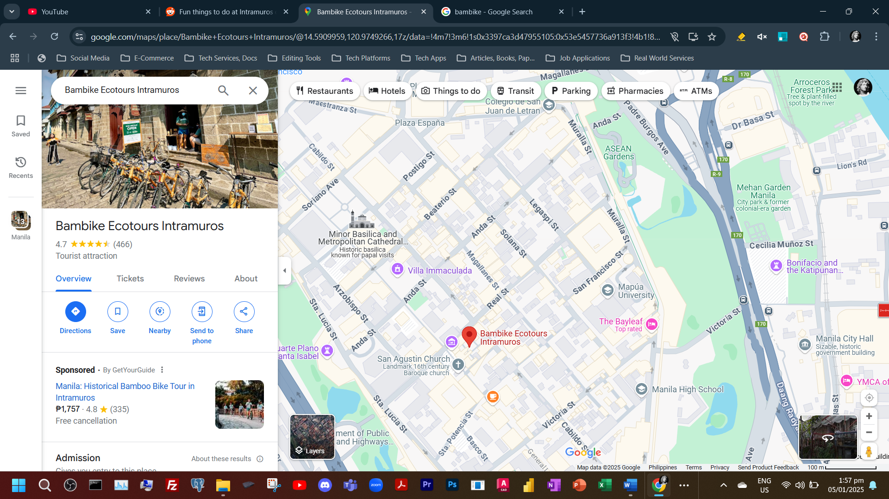

Kilangan magdala ng ID kasi I think iniiwan dito sa establishment para after maexchange mo na yung id with your rented bike if your done biking

Fort Santiago (₱75 entrance)

Visit churches (San Agustin, Manila Cathedral)

San Agustin Museum (₱200 sabi online)

Mga Cafe: Belfry Cafe, La Cathedral Cafe, Papa Kape (inside Fort Santiago), Cafes inside Casa Manila

Pwede mo rin visit yung bagong Binondo-Intramuros Bridge or the Pasig river esplanade sa Jones Bridge pero baka lakaran